**1. Introduction**

**Java?**

Java is a general-purpose, class-based, object-oriented programming LANGUAGE designed for having lesser implementation dependencies.

Characteristics:

* Easy to write and run
* Used to create complete applications distributed across servers.
* Better equipped for mobile development.

**Python**

Characteristics:

* Takes less time to write the code
* It doesn’t need a commercial license to maintain security updates.
* Runs slower than java

A need arises to make data persist beyond the execution of the process or application that created it. Applications must be able to store and retrieve data and therefore data must be persistent.

**2. File system management**

**2.1. File systems**

A file is an abstraction of the operating system for generic data storage. The part of the operating system that handles files is called the "file system". Today the most popular file systems are:

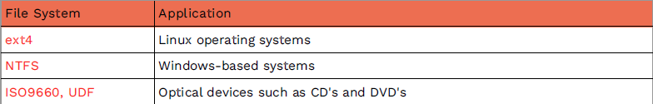

All file systems share the same aspects:

* They are organized in hierarchical structures of directories.
* The name of the file is related to its position in the directory tree containing it.
* Files usually have a series of associated metadata: creation date, permissions…

**2.2. Paths: file naming**

In today’s computer systems is essential a system that allows an efficient location management.

The name of a file is known as its **path**. Example of a Unix like system:

*/home/admin/documents/AccessFiles/unit1.txt*

2.2.1. Linux

- In Linux, whatever the device or the actual remote system where the file will be stored, the path will always have the same form.

- On Linux operating systems, all files are contained in a root directory or in directories hanging from it.

*/home/admin/documents/AccessFiles/unit1.txt*

2.2.2. Windows

The strategy of Windows is to keep each of the systems and devices to which it has access very distinct.

We refer to the identification of devices and systems with a letter of the alphabet followed by a colon. This drive may itself contain files or directories.

*Option a --> F:\Documents\AccessFiles\Unit1.txt*

*Option b --> \\ServerHS\Documents\AccessFiles\Unit1.txt*

**2.3. Relative and absolute paths**

Absolute paths: are those that allow a file and its location to be uniquely identified without the need for further data

A relative path: specifies the path to a file from a reference directory, which is known as the working directory.

To distinguish a relative path from an absolute path, the key is to realise that a relative path is not preceded by the root of the file system (/ on Linux) or by a drive letter on Windows (C:\ for example).

**3. Files: types and access**

Files are structured data warehouses and it could be considered as an exchanging data resources between 2 systems: one volatile (RAM memory) and a permanent (storage devices).

We store application data in one of the following ways:

* Text files with a flat structure (e.g. .txt and .csv files)
* Text files with internal hierarchy (json, XML, HTML, etc.)
* Binary files (simple memory dump into a file)
* Databases

**3.1. Types depending on the content**

3.1.1. Text (character) file

- Designed to be read by humans.

- Also called flat files or ASCII files

- Usually the same on all computers

- Not as efficient to process

Text editor: a programme that allows you to view and/or edit text files.

Word processor: allows you to view and/or edit files in which, in addition to text, there may be other types of information that the word processor has to interpret: fonts, images, etc.

3.1.2. Binary (byte) files

- Designed to be read by programs.

- Consist of binary digits

- More efficient to process than text files

- Platform independent

- Designed to be read on the same type of computer/language as the computer that created it.

- Not possible to view the content directly.

- Examples: spreadsheet (.ods, .xls, .xlsx), images (.jpg, .pnj), video (.mp4, .avi, .mkv)

**3.2. Types depending on the access mode**

3.2.1. Sequential access

- Sequential access mechanism traverses file records in a linear fashion.

-In java sequential access can be:

- Binary: FileInputStream and FileOutputStream

- Characters: FileReader and FileWriter

3.2.2. Random access

- The direct access mode allows us to directly access the information of the i-th byte without the need to go through all of them.

- In Java, for random access we will use RandomAccessFile

**3.3. File operations**

The operations we can perform on any file (regardless of its type):

• File creation

• Opening the file

• Closing the file

• Reading data from the file

• Writing data to the file

Once opened, the operations that can be carried out are classified as follows:

• Additions

• Deletions

• Modifications

• Queries

**4. Java File Management**

There is no standard way to reference a file; to overcome this dependency, Java has developed the File class which allows the reference of a file to be abstracted independently of the operating system's own notation.

**4.1. The File class. General aspects**

* The file class is used to manage the file system.
* The class doesn’t represent the content of any file, but rather the path where it is located.
* It can represent: files / series of files, folders or directories.
* The File class doesn’t have any kind of utility to obtain a sorted list.
* The File class has no method or mechanism to modify the associated path
* We achieve full independence of the OS notation.

Functionalities of the file class:

* Manipulation / consultation of the structure itself (creation, deletion, obtaining location).
* Functions for manipulating and querying the particular characteristics of the elements (names, size or capacity, etc.).
* Functions for manipulating and querying attributes: to write permissions, execution permissions, hiding attributes, etc.

**4.2. File operations. INPUT/OUTPUT Streams**

The Java I/O system has different classes defined in the java.io package. It uses the **Stream** abstraction to handle communication between a source and a destination.

A **stream** is an object that enables the flow of data between a program and some I/O device or file:

* If the data flows into a program: input stream from the keyboard, from file…
  1. *Scanner keyboard = new Scanner(System.in);*
* If the data flows out of a program: output stream to a screen, to a file…
  1. *System.out.println("Output stream");*

By default, the information in a stream will be written and read serially.

There are two types of streams:

4.2.1 Byte streams (8 bits)

• Performs byte I/O operations.

• Oriented to binary data operations.

• All types of byte streams descend from InputStream and OutputStream.

1. InputStream

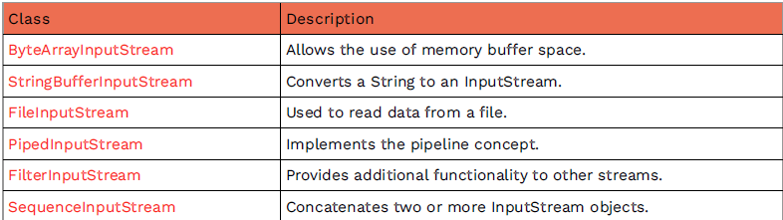

1. OutputStream

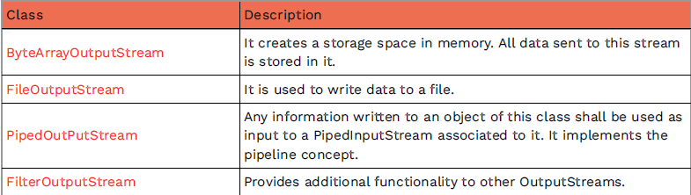

4.2.2 Character streams (16-bit)

• Perform character I/O operations.

• Defined in Reader and Writer classes:

* 1. handle Unicode character streams

• Supports 16-bit Unicode characters

• We have “bridge classes", which convert from byteStream to characterStream:

* 1. InputStreamReader: Converts an InputStream to a Reader
  2. OutputStreamWriter: Converts an OutputStream into a Writer.

Important character stream classes:

* FileReader and FileWriter: Reads and writes characters to files
* CharArrayReader and CharArrayWriter: Read and write character arrays
* BufferedReader and BufferedWriter: Used to use an intermediate buffer between the program and the source or target file.



4.2.3. Using buffers

- A buffer is a data structure that allows chunked access to a collection of data.

- Buffers are useful to avoid storing large amounts of data in memory.

**5. File Access with Java**

* Java File class is an abstract representation of a file or directory pathname.
* Java File class contains several methods for working with the pathname:
  1. deleting and renaming files,
  2. creating new directories,
  3. listing the contents of a directory,
  4. determining common attributes of files and directories
* A pathname can be either absolute or relative.
* We invoke it with the ***getParent***() method.
* First we create it by passing the filename or directory name to it.
* Instances of the File class are immutable (the abstract pathname will never change)

**5.1. How to create a file Object**

A File object is created by passing in a string that represents the name of a file, a String, or another File object.

**Unix**:

*File fiUnix = new File("/usr/local/bin/ada.txt");*

**Windows:**

*File fiWindows = new File("C:\\Users\\Admin\\DocumentsandFiles\\ada.txt");*

**5.3. Methods of File Class in Java**

File Class meethods classification:

* Get
* Set
* Can
* IS
* FUNCTIONAL

**5.3.1.GET methods**

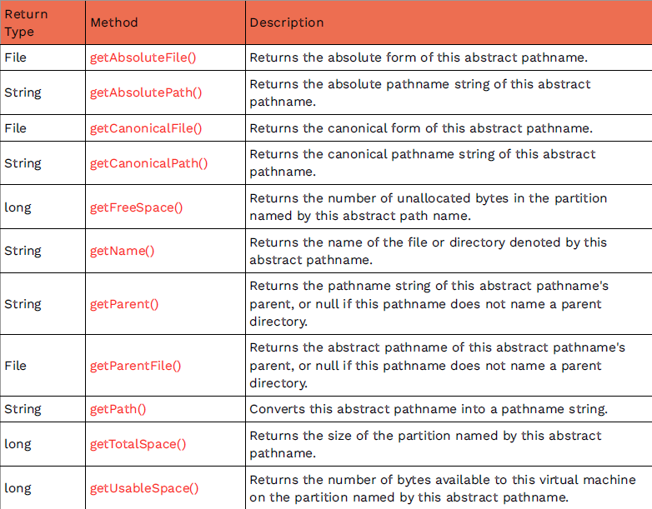

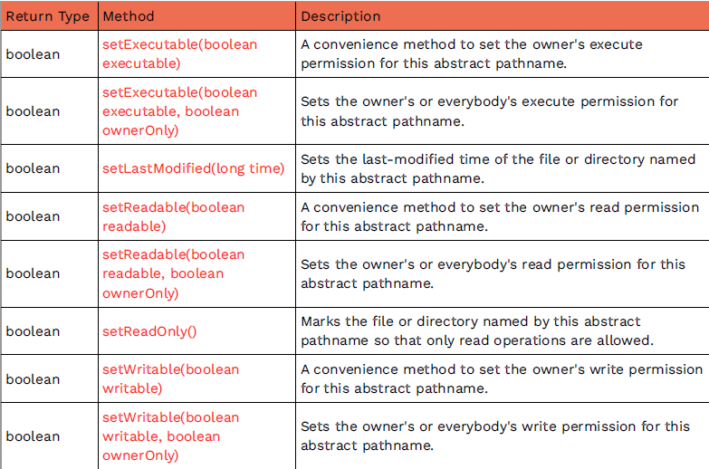**5.3.2. SET method**

**5.3.3. CAN method**

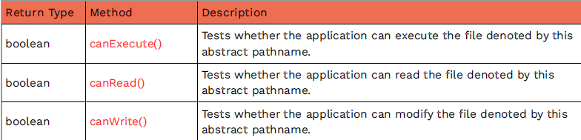

**5.3.4. IS method**

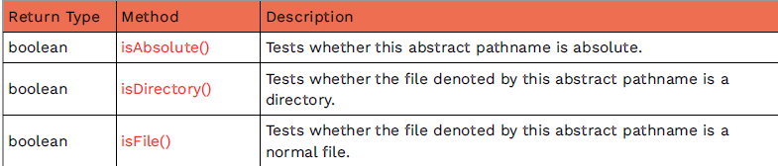

**5.3.5. FUNCTIONAL methods**

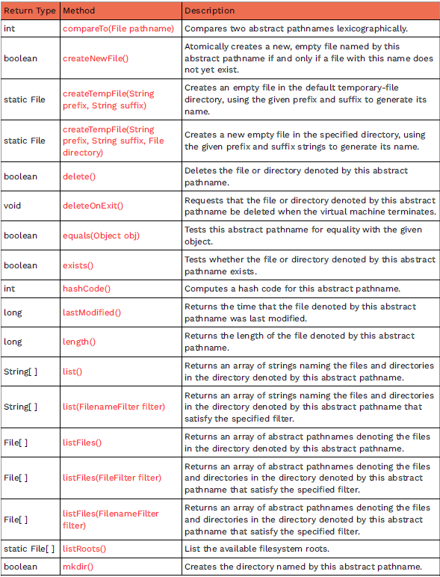

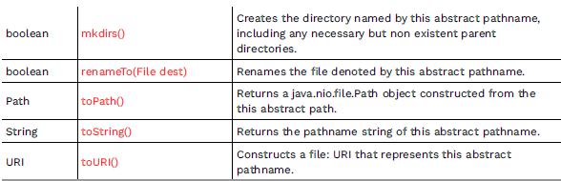

**5.4. Constructors of Java File Class**

We need to create a new instance to work with the file/folder.

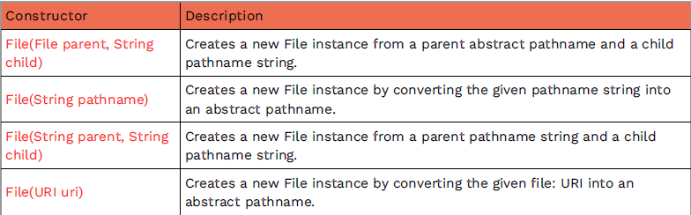



**5.5. Hungarian notation**

* This notation is a commonly used system for creating variable names and consists of lowercase prefixes added to variable names to indicate their type.
* The rest of the name indicates, as clearly as possible, the function performed by the variable.

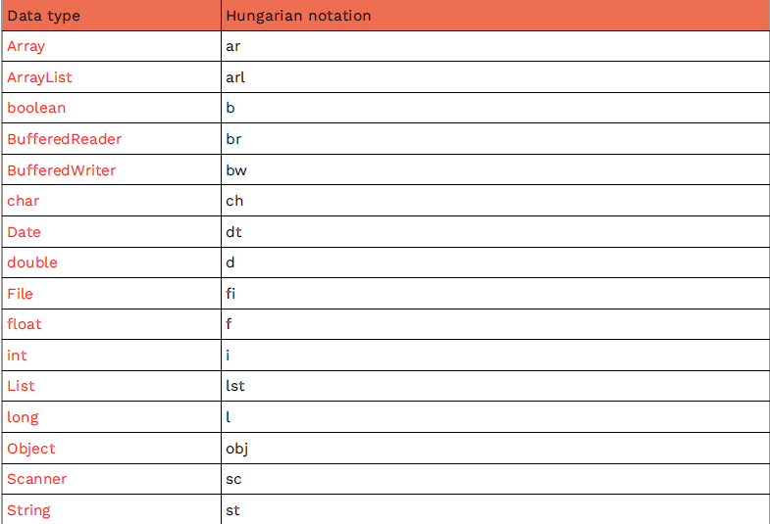

**5.6. Examples**

1. Program to check if a file or directory physically exists or not.

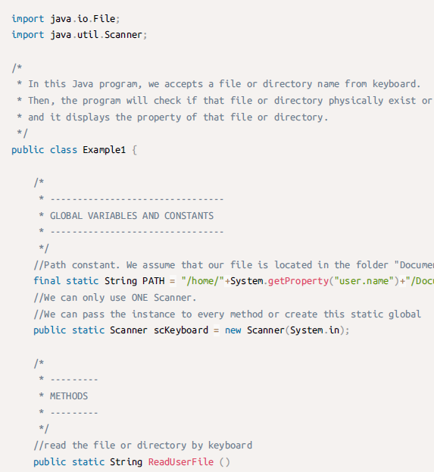

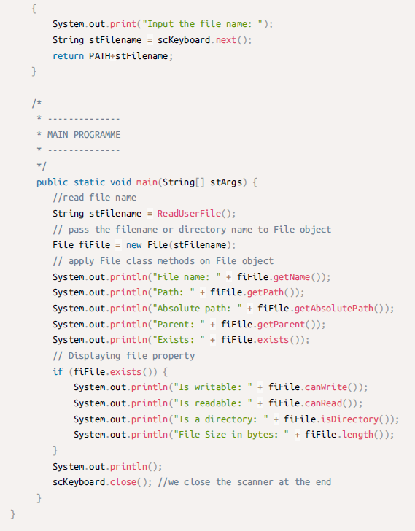

2. Program to display all the contents of a directory. Here we will accept a directory name from the keyboard and then display all the contents of the directory. For this purpose, list() method can be used as:

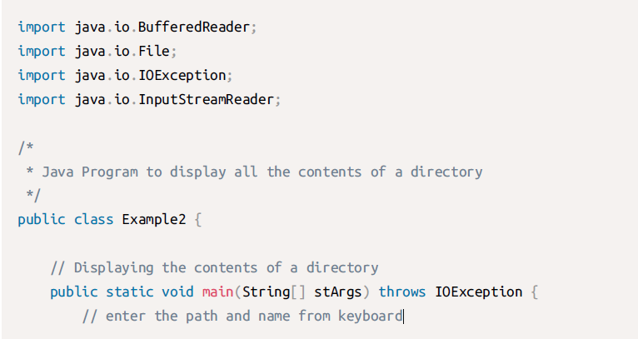

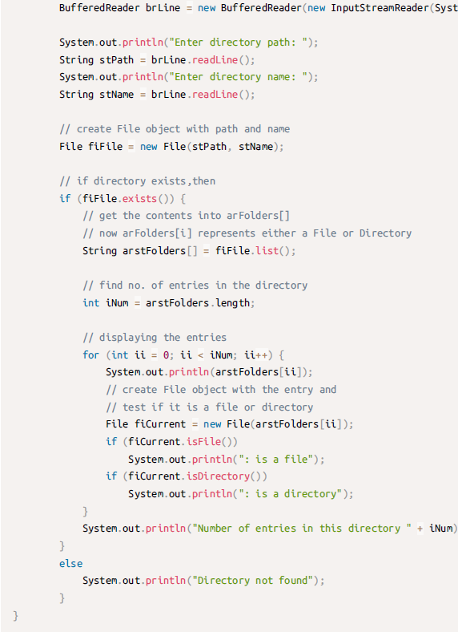

3. Full example:

- Reads a file to access its information.

- Then checks if the file exists.

- Try it placing a file called “example1.txt” on the root folder of a new Java project

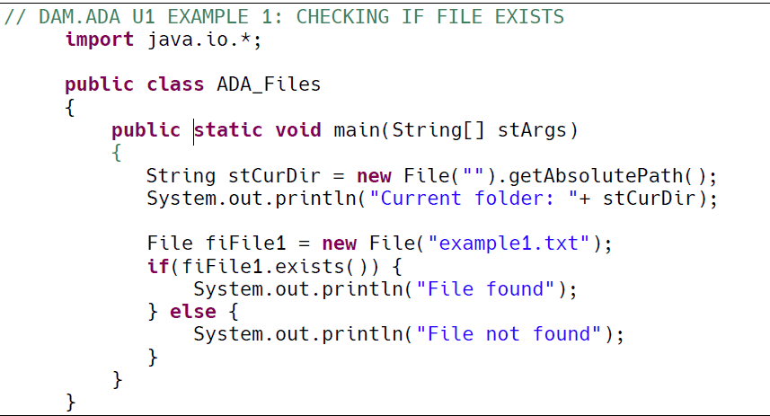

**6. Accessing Text Files in Java**

To work with text files we will use:

• FileReader to read.

• FileWriter to write.

Whenever we work with these classes we must always carry out a correct management of exceptions since they can produce:

• FileNotFoundException → In case of not finding the file.

* 1. Exceptions are referred to as a passive error handling.

• IOException → When some kind of writing error occurs. (input/output operations)



* We need to catch the exception and close the file either if the operation goes well or bad.
* Using finally, Java remembers that the try-catch block contained finally and calls the finally block even after leaving the try or catch block.

**6.1. FileReader method (one option to read)**

In Java, to open and read a text file, we must:

• Create an instance of the File class.

• Create an input stream with the FileReader class.

• Perform the pertinent reading operations.

• Close the file with the .close() method.

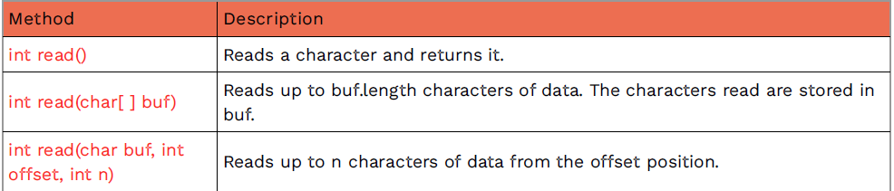

1. Example (reading a file character by character):

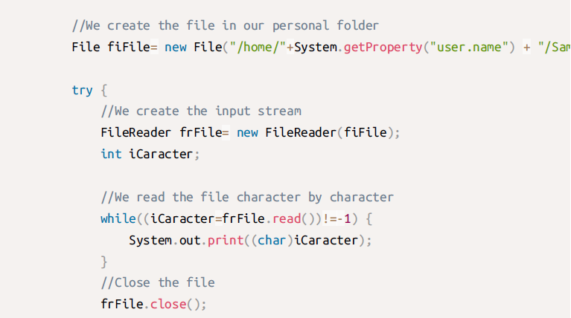

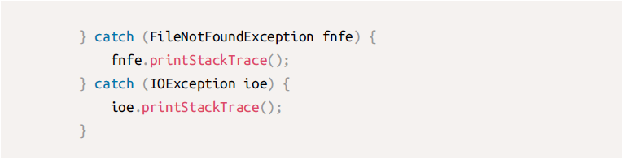

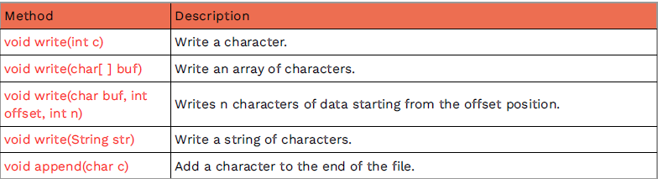**6.2. FIleWriter (one option to write)**

In Java, when writing to a text file we must:

• Create an instance of the File class.

• Create an output stream with FileWriter.

• We perform the writing operations.

• Close the file with the .close() method.

Example 1:

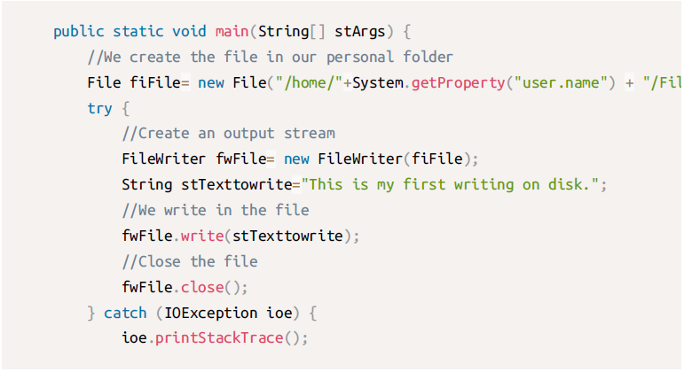

Example 2:

In the following example we are going to write the entire contents of an array into a file.

If the file already contained information previously, we will overwrite its content when we write to it. If our intention is to add new information, we must create the output stream in the following way: 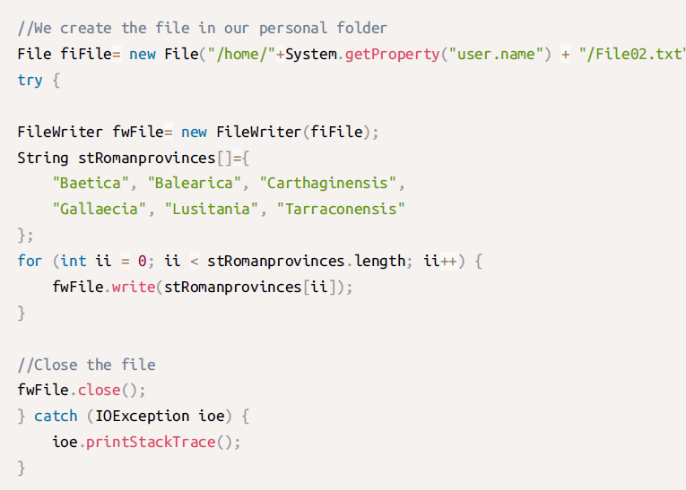

*Filewriter fw = new FileWriter(f, true)*

true → Append the information to the end of the file.

false → Delete the previous content to insert the new one.

**6.3. BufferedReader** (another option to read files)

- a more advanced management of file reading.

- read single characters, arrays or complete lines such as strings.

- is the BufferedReader itself that remembers the last position of the file read.

- The readLine() method reads a line of the file and returns it in the form of a String.

- To create a BufferedReader we need to start from the FileReader class. This is because the class that actually manages the stream is FileReader. BufferedReader uses it to do a buffered read.

Example:

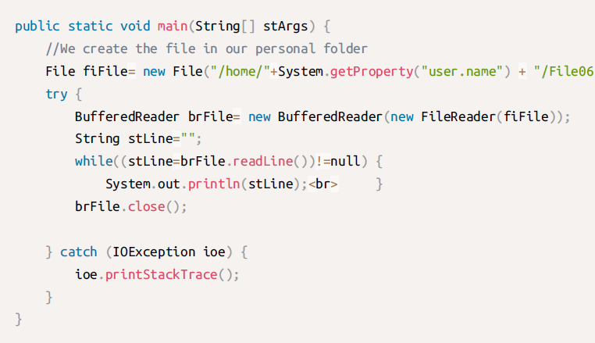

Example 2:

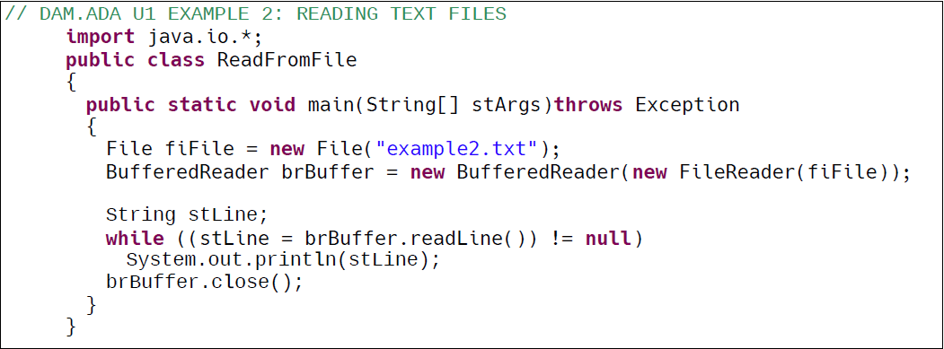

**6.4. BufferedWriter** (another writing method)

• The .write() method writes a line to our file.

• The .newLine() method writes a line break.

Example:

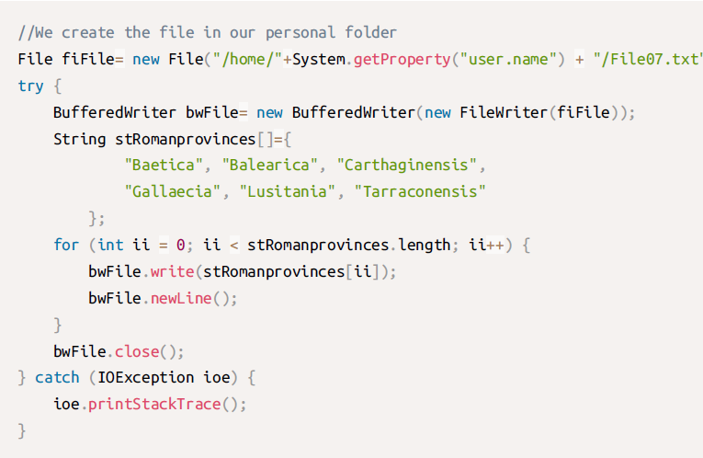

Example 2:

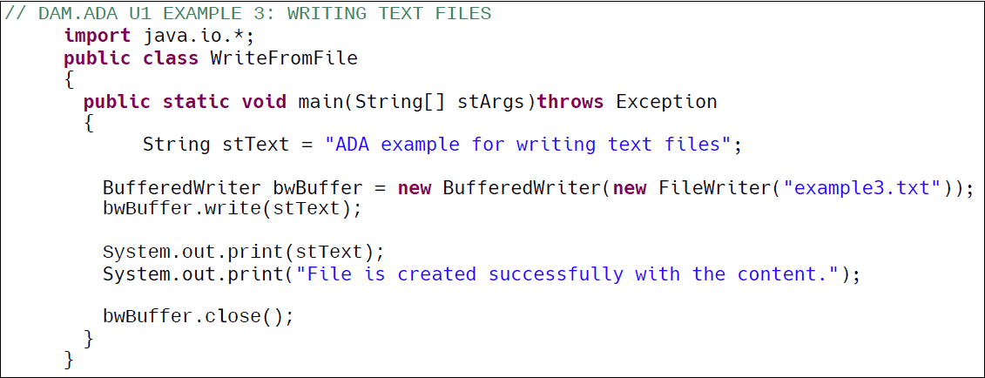

Example 3:

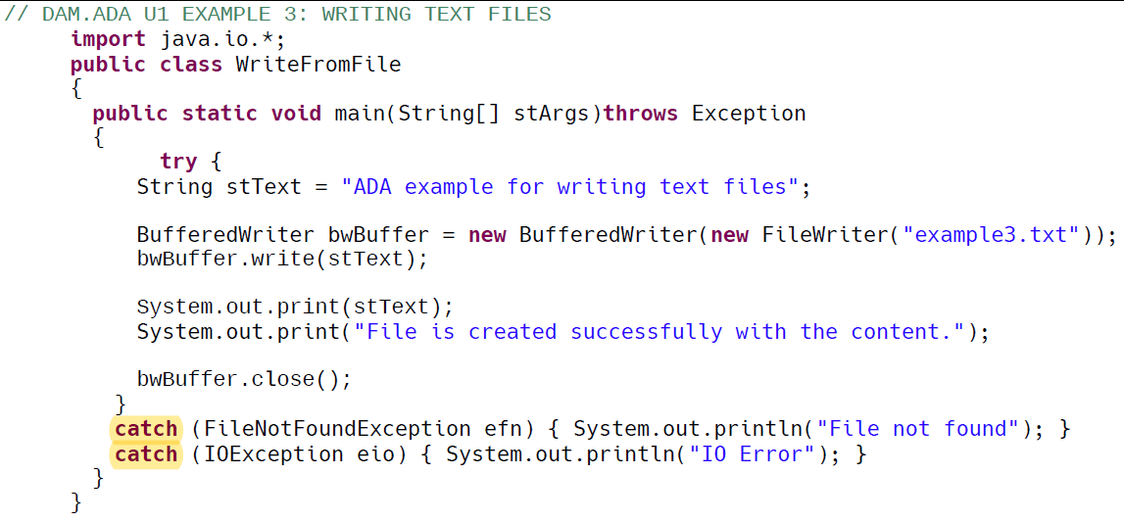

**6.5. PrintWriter**

- println also inserts a line break.

- To build a PrintWriter, once again, we need a FileWriter.

Example:

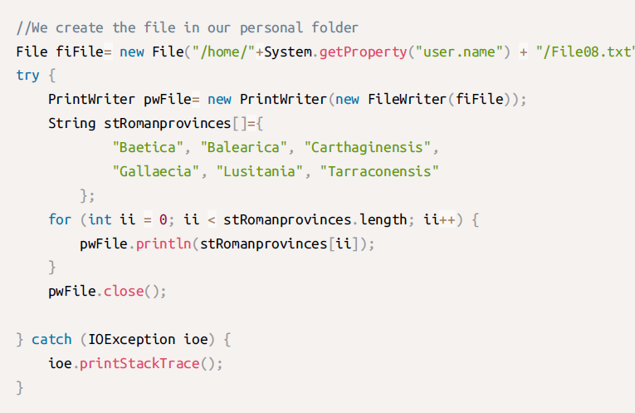

**EXERCISES**(not corrected )

Try to solve these 10 exercises. Feel free to share your doubts at the UNIT forum.

1. Write a Java program to get a list of all file/directory names from the given.

package accessAdades;

import java.io.BufferedReader;

import java.io.File;

import java.io.IOException;

import java.io.InputStreamReader;

public class Assessable {

public static void main(String[] args) throws IOException {

// **TODO** Auto-generated method stub

BufferedReader brLine = new BufferedReader (new InputStreamReader(System.***in***));

//enter the path and name from keyboard

System.***out***.println("Enter directory path: ");

String stPath = brLine.readLine();

//create a file object with path and name

File fiFile = new File(stPath);

//if directory exists then

if(fiFile.exists()) {

//get content into an arraylist

String arstFolders[] = fiFile.list();

//find nr. of entries

int iNum = arstFolders.length;

//display entries

for(int ii=0; ii< iNum; ii++) {

System.***out***.println(arstFolders[ii]);

}

System.***out***.println("Number of entries in this directory: " + iNum);

}

else

System.***out***.println("Directory not found");

}

}

**Solution 1.2:**

import java.io.File;

import java.util.Scanner;

public class Exercise1 {

//Path constant. We assume that we want to list our personal folder

**final static String PATH = "/home/"+System.getProperty("user.name")+"/";**

//We can only use ONE Scanner.

//We can pass the instance to every method or create this **static global**

public static Scanner scKeyboard = new Scanner(System.in);

/*

* METHODS

*/

//Read the path by keyboard

public static String Keyboardmethod ()

{

**System.out.print("Input the path: ");**

**String stPath = scKeyboard.next();**

**return stPath;**

}

/*

* MAIN PROGRAMME

*/

public static void main(String stArgs[])

{

System.out.println("-- Exercise 01 --");

String stPath = PATH; //read the path by constant

//String stPath = Keyboardmethod(); //read the path by keyboard

try {

File fiFolder = new File(stPath);

String[] stFolderContent = fiFolder.list(); //we list and save all the contents into an array

//Check whether the folder is empty or not

if(stFolderContent.length > 0) {

for(String stElement:stFolderContent) {

System.out.println(stElement);

}

}

else {

System.out.println("The given path is empty.");

}

} catch (Exception exe) {

System.out.println("Error, the given path does not exist.");

}

System.out.println();

scKeyboard.close(); //we close the scanner at the end

}

}

2. Write a Java program to get specific files by extensions from a specified folder.

package accessAdades;

import java.io.BufferedReader;

import java.io.File;

import java.io.IOException;

import java.io.InputStreamReader;

import java.util.ArrayList;

import java.util.List;

public class Assesable2 {

public static void main(String[] args) throws IOException {

// 2. Write a Java program to get specific

//files by extensions from a specified folder.

BufferedReader brLine = new BufferedReader (new InputStreamReader(System.***in***));

System.***out***.println("Enter directory path: ");

String stPath = brLine.readLine();

System.***out***.println("Enter extention of files: ");

String stExt = brLine.readLine();

// call method to get files with specified extension

List<String> filteredFiles = *getFilesByExtension*(stPath, stExt);

//print the filtered files

System.***out***.println("FIles with extention '"+ stExt + " ':" );

for (String fileName : filteredFiles) {

System.***out***.println(fileName);

}

}

private static List<String> getFilesByExtension(String stPath , String stExt) {

List<String> filteredFiles = new ArrayList<>();

File folder = new File(stPath);

//check if directory exists

if(folder.exists() && folder.isDirectory()) {

//list the files in the folder in an array list

File[] files = folder.listFiles();

if(files != null) {

for (File file : files) {

if(file.isFile()) {

String fileName = file.getName();

//check if it has the extension

if(fileName.endsWith(stExt)) {

filteredFiles.add(fileName);

}

}

}

}

}else {

System.***err***.println("FOlder not found or is not a directory");

}

return filteredFiles;

}

}

**Solution 2.2**

import java.io.File;

import java.util.Scanner;

public class Exercise2 {

/*

* GLOBAL VARIABLES AND CONSTANTS

*/

//Path constant. We assume that our files are located in the folder "Documentos"

final static String PATH = "/home/"+System.getProperty("user.name")+"/Documentos/";

//We can only use ONE Scanner.

//We can pass the instance to every method or create this static global

public static Scanner scKeyboard = new Scanner(System.in);

/*

* METHODS

*/

//read the file extension by keyboard

public static String ReadFileExtension ()

{

System.out.print("Input the path: ");

String stExtension = scKeyboard.next();

return stExtension;

}

/*

* MAIN PROGRAMME

*/

public static void main(String stArgs[]){

System.out.println("-- Exercise 02 --");

try {

File fiFolder = new File(PATH);

String[] stFolderContent = fiFolder.list(); //contents list of the given path

String stFileExt = ReadFileExtension(); //read the file extension by keyboard

//check if the folder has any content

if(stFolderContent.length > 0) {

boolean bFoundExt = false; //test if there is at least a file with the given extension

//traverse the array to show all the files

for(String stElement:stFolderContent) {

if(stElement.toLowerCase().endsWith(stFileExt)){

bFoundExt = true;

System.out.println(stElement);

}

}

if(!bFoundExt) {

System.out.println("There are no files with the given extension.");

}

}

else {

System.out.println("The given path is empty.");

}

scKeyboard.close(); //we close the scanner at the end

}

catch (Exception exe) {

System.out.println("Error, the given path does not exist.");

}

}

}

3. Write a Java program to check if a file or directory specified by pathname exists or not.

public class Assesable2 {

public static void main(String[] args) throws IOException {

// 3. Write a Java program to check if a file

//or directory specified by pathname exists or not.

BufferedReader brLine = new BufferedReader (new InputStreamReader(System.***in***));

//enter the path and name from keyboard

System.***out***.println("Enter directory/file: ");

String stPath = brLine.readLine();

File fileFolder = new File(stPath);

//check if file or directory exists

if (fileFolder.exists()) {

System.***out***.println(fileFolder + " exists");

}else {

System.***out***.println(fileFolder + " doesn't exist"); }

}

}

**Option 3.2.**

import java.io.File;

import java.util.Scanner;

public class Exercise3 {

/*

* GLOBAL VARIABLES AND CONSTANTS

*/

//We can only use ONE Scanner.

//We can pass the instance to every method or create this static global

public static Scanner scKeyboard = new Scanner(System.in);

/*

* METHODS

*/

//read the path by keyboard

public static String ReadPath ()

{

System.out.print("Input the path: ");

String stPath = scKeyboard.next();

return stPath;

}

/*

* MAIN PROGRAMME

*/

public static void main(String stArgs[]){

System.out.println("-- Exercise 03 --");

String stPath = ReadPath(); //read the path by keyboard

File fiPath = new File(stPath);

if (fiPath.exists()) {

System.out.println("The given path exists.");

}

else {

System.out.println("The given path does not exist.");

}

System.out.println();

scKeyboard.close(); //we close the scanner at the end

}

}

4. Write a Java program to get last modified time of a file.

public class Assesable2 {

public static void main(String[] args) throws IOException {

BufferedReader brLine = new BufferedReader (new InputStreamReader(System.***in***));

//enter the path and name from keyboard

System.***out***.println("Enter directory/file: ");

String stPath = brLine.readLine();

File fileFolder = new File(stPath);

long milisegons = fileFolder.lastModified();

Date data = new Date(milisegons);

System.***out***.println("Last modified date (ms): " + milisegons);

System.***out***.println("Last modified date (data): " + data);

}

}

**Option 4.2.**

import java.io.File;

import java.util.Scanner;

import java.util.Date;

public class Exercise4 {

/*

* GLOBAL VARIABLES AND CONSTANTS

*/

//We can only use ONE Scanner.

//We can pass the instance to every method or create this static global

**public static Scanner scKeyboard = new Scanner(System.in);**

/*

* METHODS

*/

//read the file by keyboard

public static String ReadFile ()

{

System.out.print("Input the file: ");

String stFileName = scKeyboard.next();

return stFileName;

}

/*

* MAIN PROGRAMME

*/

public static void main(String stArgs[]){

System.out.println("-- Exercise 04 --");

String stFile = ReadFile(); //read the file by keyboard

File fiFile = new File(stFile);

if(fiFile.exists()) {

**Date dtLastModifiedDate = new Date(fiFile.lastModified());**

System.out.println(dtLastModifiedDate);

}

else {

System.out.println("The file does not exist.");

}

System.out.println();

scKeyboard.close(); //we close the scanner at the end

}

}

5. Write a Java program to get file size in bytes, Kb, Mb.

import java.io.File;

import java.util.Scanner;

public class Exercise5 {

/*

* GLOBAL VARIABLES AND CONSTANTS

*/

//We can only use ONE Scanner.

//We can pass the instance to every method or create this static global

public static Scanner scKeyboard = new Scanner(System.in);

/*

* METHODS

*/

//read the file by keyboard

public static String ReadFile ()

{

System.out.print("Input the file: ");

String stFileName = scKeyboard.next();

return stFileName;

}

/*

* MAIN PROGRAMME

*/

public static void main(String stArgs[]){

System.out.println("-- Exercise 05 --");

String stFile = ReadFile(); //read the file by keyboard

File fiFile = new File(stFile);

if(fiFile.exists()) {

**long lSizeBytes = fiFile.length();**

**double dSizeKilobytes = lSizeBytes / 1024;**

**double dSizeMegabytes = dSizeKilobytes / 1024;**

System.out.println("The file size is "

+ lSizeBytes + " bytes, "

+ dSizeKilobytes + "Kb, "

+ dSizeMegabytes + " Mb.");

}

else {

System.out.println("The file does not exist.");

}

System.out.println();

scKeyboard.close(); //we close the scanner at the end

}

}

6. Write a Java program to read a file content line by line.

public class Assesable2 {

public static void main(String[] args) throws IOException {

BufferedReader brLine = new BufferedReader (new InputStreamReader(System.***in***));

//enter the path and name from keyboard

System.***out***.println("Enter file: ");

String stFile = brLine.readLine();

File fileFolder = new File(stFile);

try {

BufferedReader bwReader = new BufferedReader(new FileReader(fileFolder));

String stLine;

while ((stLine = bwReader.readLine()) != null)

System.***out***.println(stLine);

bwReader.close();

}

catch (IOException ioe) {

System.***out***.println("Error: " + ioe);

}

}

}

import java.io.BufferedReader;

import java.io.FileNotFoundException;

import java.io.FileReader;

import java.io.IOException;

import java.util.Scanner;

public class Exercise6br {

/*

* GLOBAL VARIABLES AND CONSTANTS

*/

//Path constant. We assume that our file is located in the folder "Documentos"

final static String PATH = "/home/"+System.getProperty("user.name")+"/Documentos/";

//We can only use ONE Scanner.

//We can pass the instance to every method or create this static global

public static Scanner scKeyboard = new Scanner(System.in);

/*

* METHODS

*/

//read the file by keyboard

public static String ReadUserFile ()

{

System.out.print("Input the file name: ");

String stFilename = scKeyboard.next();

return PATH+stFilename;

}

/*

* MAIN PROGRAMME

*/

public static void main(String stArgs[]) throws IOException {

System.out.println("-- Exercise 06 (BufferedReader version) --");

BufferedReader brFile = null;

String stLine = "";

try {

//read file name

String stFilename = ReadUserFile();

//open file with buffer

brFile = new BufferedReader( new FileReader(stFilename));

while ((stLine = brFile.readLine()) != null){

System.out.println(stLine);

}

System.out.println();

brFile.close(); //close the buffer

scKeyboard.close(); //we close the scanner at the end

} catch (FileNotFoundException fne) {

System.err.println("File not found");

} catch (IOException ioe) {

System.err.println("Unable to read the file.");

}

}

}

7. Write a Java program to store text file content line by line into an array. (it doesn’t say anything after writing the file)

package accessAdades;

import java.io.BufferedReader;

import java.io.BufferedWriter;

import java.io.File;

import java.io.FileReader;

import java.io.FileWriter;

import java.io.IOException;

import java.io.InputStreamReader;

public class Assesable2 {

public static void main(String[] args) throws IOException {

// 7. Write a Java program to store text

//file content line by line into an array.

BufferedReader brLine = new BufferedReader (new InputStreamReader(System.***in***));

//enter the path and name from keyboard

System.***out***.println("Enter file: ");

String stFile = brLine.readLine();

File fileFolder = new File(stFile);

try {

BufferedWriter bwFile = new BufferedWriter(new FileWriter(fileFolder));

String stExamples[]= {

"This", "is", "the", "7", "exercise"

};

for (int ii = 0; ii < stExamples.length; ii++ ) {

bwFile.write(stExamples[ii]);

bwFile.newLine();

}

bwFile.close();

}

catch (IOException ioe) {

System.***out***.println("Error: " + ioe);

}

}

}

**Option 7.2.**

import java.io.File;

import java.io.FileNotFoundException;

import java.io.IOException;

import java.nio.file.Files;

import java.util.List;

import java.util.ArrayList;

import java.util.Scanner;

public class Exercise7nio {

/*

* GLOBAL VARIABLES AND CONSTANTS

*/

//Path constant. We assume that our file is located in the folder "Documentos"

final static String PATH = "/home/"+System.getProperty("user.name")+"/Documentos/";

//We can only use ONE Scanner.

//We can pass the instance to every method or create this static global

public static Scanner scKeyboard = new Scanner(System.in);

/*

* METHODS

*/

//read the file by keyboard

public static String ReadUserFile ()

{

System.out.print("Input the file name: ");

String stFilename = scKeyboard.next();

return PATH+stFilename;

}

/*

* MAIN PROGRAMME

*/

public static void main(String stArgs[]) throws IOException {

System.out.println("-- Exercise 07 (NIO) --");

try {

//read file name

String stFilename = ReadUserFile();

//open file

File fiFile = new File(stFilename);

//read all lines

List<String> lstFileLines = Files.readAllLines(fiFile.toPath());

//traverse and save into the array line by line

List<String> arlLines = new ArrayList<String>();

for(int ii = 0; ii < lstFileLines.size(); ii++) {

arlLines.add(lstFileLines.get(ii));

System.out.println("Array line " + (ii+1) + ": " + arlLines.get(ii));

}

System.out.println();

scKeyboard.close(); //we close the scanner at the end

} catch (FileNotFoundException fne) {

System.err.println("File not found");

} catch (IOException ioe) {

System.err.println("There was an I/O error. Unable to read the file.");

}

}

}

8. Write a Java program to write and read a plain text file.

package accessAdades;

import java.io.BufferedReader;

import java.io.BufferedWriter;

import java.io.File;

import java.io.FileReader;

import java.io.FileWriter;

import java.io.IOException;

import java.io.InputStreamReader;

public class Assesable2 {

public static void main(String[] args) throws IOException {

// 8. Write a Java program to write and read a plain text file.

BufferedReader brLine = new BufferedReader (new InputStreamReader(System.***in***));

//enter the path and name from keyboard

System.***out***.println("Enter file: ");

String stFile = brLine.readLine();

//create an object with the path we were given

File fileFolder = new File(stFile);

//a try catch for errors

try {

//we first read the file

BufferedReader bwReader = new BufferedReader(new FileReader(fileFolder));

String stLine;

while ((stLine = bwReader.readLine()) != null)

System.***out***.println(stLine);

//now we write the file

BufferedWriter bwFile = new BufferedWriter(new FileWriter(fileFolder));

String stExamples[]= {

"This", "is", "the", "8", "exercise"

};

for (int ii = 0; ii < stExamples.length; ii++ ) {

bwFile.write(stExamples[ii]);

bwFile.newLine();

}

//close the scanners and the writers

bwFile.close();

bwReader.close();

}

catch (IOException ioe) {

System.***out***.println("Error: " + ioe);

}

}

}

**Option 8.2.**

import java.io.BufferedReader;

import java.io.IOException;

import java.util.Scanner;

import java.io.FileReader;

import java.io.FileWriter;

/**

* -------------------------------------------------------------------------------------------

* @author Abelardo Martínez

* Program to write and read a plain text file

* -------------------------------------------------------------------------------------------

*/

public class Exercise8 {

/*

* --------------------------------

* GLOBAL VARIABLES AND CONSTANTS

* --------------------------------

*/

//Path constant. We assume that our file is located in the folder "Documentos"

final static String PATH = "/home/"+System.getProperty("user.name")+"/Documentos/";

//We can only use ONE Scanner.

//We can pass the instance to every method or create this static global

public static Scanner scKeyboard = new Scanner(System.in);

/*

* ---------

* METHODS

* ---------

*/

//read the file name by keyboard

public static String ReadUserFile ()

{

System.out.print("Input the file name: ");

String stFilename = scKeyboard.next();

return PATH+stFilename;

}

/*

* --------------

* MAIN PROGRAMME

* --------------

*/

public static void main(String stArgs[]){

System.out.println("-- Exercise 08 --");

StringBuilder sbLine = new StringBuilder(); //dynamic string array

String stLine = ""; //current line

try

{

//read file name

String stFilename= ReadUserFile();

FileWriter fwFile = new FileWriter(stFilename,false); //parameter "false" indicates that we'll create or overwrite the file

//appends the string to the file

fwFile.write("Java Input/Output exercises\n");

fwFile.close();

//read the file content

BufferedReader brFile = new BufferedReader(new FileReader(stFilename));

//read the file content

while ((stLine = brFile.readLine()) != null) {

sbLine.append(stLine); //append to the dynamic string array

sbLine.append(System.lineSeparator()); //insert a carriage return

System.out.println(stLine);

}

brFile.close(); //close the buffer

}

catch(IOException ioe) {

System.err.println("IOException: " + ioe.getMessage());

}

}

}

9. Write a Java program to append text to an existing file.

public class Assesable2 {

public static void main(String[] args) throws IOException {

// 9. Write a Java program to append text to an existing file.

BufferedReader brLine = new BufferedReader (new InputStreamReader(System.***in***));

//enter the path and name from keyboard

System.***out***.println("Enter file: ");

String stFile = brLine.readLine();

//create an object with the path we were given

File fileFolder = new File(stFile);

//a try catch for errors

try {

//now we write the file

BufferedWriter bwFile = new BufferedWriter(new FileWriter(fileFolder));

String stExamples[]= {

"This", "is", "the", "9", "exercise"

};

for (int ii = 0; ii < stExamples.length; ii++ ) {

bwFile.append(stExamples[ii]);

bwFile.newLine();

}

//close the scanners and the writers

bwFile.close();

}

catch (IOException ioe) {

System.***out***.println("Error: " + ioe);

}

}

}

**Solution 9.2.**

import java.io.BufferedReader;

import java.io.FileNotFoundException;

import java.io.IOException;

import java.util.Scanner;

import java.io.FileReader;

import java.io.FileWriter;

/**

* -------------------------------------------------------------------------------------------

* @author Abelardo Martínez

* Program to append text to an existing file

* -------------------------------------------------------------------------------------------

*/

public class Exercise9 {

/*

* --------------------------------

* GLOBAL VARIABLES AND CONSTANTS

* --------------------------------

*/

//Path constant. We assume that our file is located in the folder "Documentos"

final static String PATH = "/home/"+System.getProperty("user.name")+"/Documentos/";

//We can only use ONE Scanner.

//We can pass the instance to every method or create this static global

public static Scanner scKeyboard = new Scanner(System.in);

/*

* ---------

* METHODS

* ---------

*/

//read the string to append to the file

public static String ReadTextToAppend ()

{

System.out.print("Type the text to append: ");

String stLine = scKeyboard.nextLine(); //to allow spaces

return stLine;

}

//read the file name by keyboard

public static String ReadUserFile ()

{

System.out.print("Input the file name: ");

String stFilename = scKeyboard.next();

//we don't close the scanner because we'll be used in another function

return PATH+stFilename;

}

/*

* --------------

* MAIN PROGRAMME

* --------------

*/

public static void main(String stArgs[]){

System.out.println("-- Exercise 09 --");

StringBuilder sbLine = new StringBuilder(); //dynamic string array

String stLine = ""; //current line

try

{

//read file name

String stFilename= ReadUserFile();

FileWriter fwFile = new FileWriter(stFilename,true); //parameter "true" indicates that we'll append to the file

//read the string to append to the file

stLine = ReadTextToAppend();

//appends the string to the file

fwFile.write(stLine+"\n");

System.out.println("New line added to the given file.");

fwFile.close();

//read the file content

BufferedReader brFile = new BufferedReader(new FileReader(stFilename));

while ((stLine = brFile.readLine()) != null)

{

sbLine.append(stLine); //append to the dynamic string array

sbLine.append(System.lineSeparator()); //insert a carriage return

//System.out.println(stLine);

}

brFile.close(); //close the buffer

System.out.println(sbLine);

scKeyboard.close(); //we close the scanner at the end

} catch (FileNotFoundException fne) {

System.out.println("The file does not exist.");

} catch(IOException ioe) {

System.err.println("IOException: " + ioe.getMessage());

}

}

}

10. Write a Java program to find the longest word in a text file. Choose the way to implement: Scanner or BufferedReader version.

public class Assesable2 {

public static void main(String[] args) throws IOException {

// 10. Write a Java program to find the

//longest word in a text file. Choose the way to

//implement: Scanner or BufferedReader version.

BufferedReader brLine = new BufferedReader (new InputStreamReader(System.***in***));

//enter the path and name from keyboard

System.***out***.println("Enter file: ");

String stFile = brLine.readLine();

//create an object with the path we were given

File fileFolder = new File(stFile);

//a try catch for errors

try {

//we first read the file

BufferedReader bwReader = new BufferedReader(new FileReader(fileFolder));

String stLine;

String stLongWord="";

while ((stLine = bwReader.readLine()) != null) {

String[] words = stLine.split("\\s+");

for (int i = 0; i < words.length; i++) {

String word = words[i];

if (word.length()> stLongWord.length()) {

stLongWord = word;

}

}

}

System.***out***.println("The longest word in the file is: " + stLongWord);

//close the scanners and the writers

bwReader.close();

}

catch (IOException ioe) {

System.***out***.println("Error: " + ioe);

}

}

}

Solution 10.2. Buffered solution

import java.io.*;

import java.util.*;

/**

* -------------------------------------------------------------------------------------------

* @author Abelardo Martínez

* Program to find the longest word in a text file. BUFFEREDREADER VERSION

* -------------------------------------------------------------------------------------------

*/

public class Exercise10br {

/*

* --------------------------------

* GLOBAL VARIABLES AND CONSTANTS

* --------------------------------

*/

//Path constant. We assume that our file is located in the folder "Documentos"

final static String PATH = "/home/"+System.getProperty("user.name")+"/Documentos/";

//We can only use ONE Scanner.

//We can pass the instance to every method or create this static global

public static Scanner scKeyboard = new Scanner(System.in);

/*

* ---------

* METHODS

* ---------

*/

//read the file name by keyboard

public static String ReadUserFile ()

{

System.out.print("Input the file name: ");

String stFilename = scKeyboard.next();

return PATH+stFilename;

}

/*

* --------------

* MAIN PROGRAMME

* --------------

*/

public static void main(String stArgs[]) throws FileNotFoundException {

System.out.println("-- Exercise 10 (BufferedReader version) --");

String stLine = ""; //line read

String stLongest_word = ""; //longest word

String stCurrent = ""; //current word

try {

String stFilename= ReadUserFile();

BufferedReader brFile = new BufferedReader(new FileReader(stFilename));

//read the file content line by line

while ((stLine = brFile.readLine()) != null) {

StringTokenizer stLineWords = new StringTokenizer (stLine);

//loop through all the words in the read line

while (stLineWords.hasMoreTokens()) {

stCurrent = stLineWords.nextToken();

if (stCurrent.length() > stLongest_word.length()) {

stLongest_word = stCurrent;

}

}

}

brFile.close(); //close the buffer

scKeyboard.close(); //we close the scanner at the end

//check if the last character is a comma or a dot, to delete it

char cLast = stLongest_word.charAt(stLongest_word.length()-1);

if ((cLast == ',') || (cLast == '.')) {

stLongest_word = stLongest_word.substring(0, stLongest_word.length()-1);

}

System.out.println("\n"+"Longest word: "+stLongest_word+"\n");

}

catch(IOException ioe) {

System.err.println("IOException: " + ioe.getMessage());

}

}

}

Solution 10.3. Scanner version

import java.util.Scanner;

import java.io.File;

import java.io.FileNotFoundException;

import java.io.IOException;

/**

* -------------------------------------------------------------------------------------------

* @author Abelardo Martínez

* Program to find the longest word in a text file. SCANNER VERSION

* -------------------------------------------------------------------------------------------

*/

public class Exercise10sc {

/*

* --------------------------------

* GLOBAL VARIABLES AND CONSTANTS

* --------------------------------

*/

//Path constant. We assume that our file is located in the folder "Documentos"

final static String PATH = "/home/"+System.getProperty("user.name")+"/Documentos/";

//We can pass the instance to every method or create this static global

public static Scanner scKeyboard = new Scanner(System.in);

/*

* ---------

* METHODS

* ---------

*/

//read the file name by keyboard

public static String ReadUserFile ()

{

System.out.print("Input the file name: ");

String stFilename = scKeyboard.next();

return PATH+stFilename;

}

//returns the longest word

public String findLongestWords() throws FileNotFoundException {

String stLongest_word = ""; //longest word

String stCurrent = ""; //current word

String stFilename= ReadUserFile();

Scanner scFile = new Scanner(new File(stFilename)); //specific scanner to read the file

//traverse the file text word by word

while (scFile.hasNext()) {

stCurrent = scFile.next();

if (stCurrent.length() > stLongest_word.length()) {

stLongest_word = stCurrent;

}

}

scFile.close(); //close the specific scanner

//check if the last character is a comma or a dot, to delete it

char cLast = stLongest_word.charAt(stLongest_word.length()-1);

if ((cLast == ',') || (cLast == '.')) {

stLongest_word = stLongest_word.substring(0, stLongest_word.length()-1);

}

System.out.println("\n"+"Longest word: "+stLongest_word+"\n");

return stLongest_word;

}

/*

* --------------

* MAIN PROGRAMME

* --------------

*/

public static void main(String stArgs[]) throws FileNotFoundException {

System.out.println("-- Exercise 10 (Scanner version) --");

try {

new Exercise10sc().findLongestWords();

scKeyboard.close();

}

catch(IOException ioe)

{

System.err.println("IOException: " + ioe.getMessage());

}

}

}

**Part 2 exercice:**

Create a program in Java to manage PRODUCTS in a shopping cart by printing and using a specific menu. After each option, the user should see the same menu until option zero is pressed. Feel free to share your doubts at the UNIT forum.

ATTENTION: Use the proper exceptions when accessing to files.

Menu options:

• Press 1 to “Ask for products until user enters zero as Product name“

◦ For every product we need the Name (String), the Price (Double) and the Units (Integer), added to the ArrayList of products.

◦ Once zero is entered as a Product name, all products will be saved in a “txt” file called “products.txt”, overwriting the whole file if exists.

◦ One product is stored per line.

◦ Afterwards, the menu will be printed again.

• Press 2 to “List all the products stored”

◦ Just read the “txt” file and print every book.

• Press 3 to “Remove all products”

◦ Just delete the “txt” file.

• Press 0 to “Exit”

package accessAdades;

import java.io.BufferedReader;

import java.io.BufferedWriter;

import java.io.File;

import java.io.FileReader;

import java.io.FileWriter;

import java.io.IOException;

import java.util.ArrayList;

import java.util.Scanner;

public class Assesable2 {

public static void main(String[] args) {

int option;

do {

System.***out***.println("************************************************");

System.***out***.println("Choose an option");

System.***out***.println("************************************************");

System.***out***.println("1. Add Products");

System.***out***.println("2. List all Products");

System.***out***.println("3. Remove all Products");

System.***out***.println("0. Exit ");

System.***out***.println("************************************************");

Scanner scScanner = new Scanner(System.***in***);

option = scScanner.nextInt();

scScanner.nextLine(); // Consume the newline character

switch (option) {

case 1:

ArrayList<Product> products = new ArrayList<>();

*addProducts*(products, scScanner);

if (!products.isEmpty()) {

*saveProductsToFile*(products);

*saveProductsToFile*(products);

}

break;

case 2:

*listProductsFromFile*();

break;

case 3:

*removeProductsFile*();

break;

default:

break;

}

} while (option != 0);

}

private static void addProducts(ArrayList<Product> products, Scanner scanner) {

while (true) {

System.***out***.print("Enter product name (or '0' to finish): ");

String name = scanner.nextLine();

if (name.equals("0")) {

break;

}

System.***out***.print("Enter product price: ");

double price = scanner.nextDouble();

System.***out***.print("Enter product units: ");

int units = scanner.nextInt();

Product product = new Product(name, price, units);

products.add(product);

scanner.nextLine();

}

}

private static void saveProductsToFile(ArrayList<Product> products) {

try (BufferedWriter writer = new BufferedWriter(new FileWriter("products.txt"))) {

for (Product product : products) {

writer.write(product.toString());

writer.newLine();

}

System.***out***.println("Products have been saved to 'products.txt'");

} catch (IOException e) {

System.***err***.println("Error saving products to file: " + e.getMessage());

}

}

private static void listProductsFromFile() {

try (BufferedReader reader = new BufferedReader(new FileReader("products.txt"))) {

String line;

while ((line = reader.readLine()) != null) {

System.***out***.println(line);

}

} catch (IOException e) {

System.***err***.println("Error reading products from file: " + e.getMessage());

}

}

private static void removeProductsFile() {

File file = new File("products.txt");

if (file.exists()) {

if (file.delete()) {

System.***out***.println("File 'products.txt' has been deleted.");

} else {

System.***err***.println("Failed to delete 'products.txt'");

}

} else {

System.***out***.println("File 'products.txt' does not exist.");

}

}

}

class Product {

private String name;

private double price;

private int units;

public Product(String name, double price, int units) {

this.name = name;

this.price = price;

this.units = units;

}

public String toString() {

return "Name: " + name + ", Price: " + price + ", Units: " + units;

}

}

**Professor solution**

Product object:

**

* =====================================================================

* Object Product

* @author Abelardo Martínez. Based and modified from Sergio Badal

* =====================================================================

*/

public class Product {

/*

* ------------------------------------------

* ATTRIBUTES

* ------------------------------------------

*/

private String stName;

private Double dPrice = 0.0;

private Integer iUnits = 0;

/*

* ------------------------------------------

* METHODS

* ------------------------------------------

*/

public Product(String stName, Double dPrice, Integer iUnits) {

this.stName = stName;

this.dPrice = dPrice;

this.iUnits = iUnits;

}

@Override

public String toString() {

return "Product=" + stName + ", Price=" + dPrice + ", Units=" + iUnits;

}

/*

* ------------------------------------------

* GETTERS

* ------------------------------------------

*/

public String getName() {

return stName;

}

public Double getPrice() {

return dPrice;

}

public Integer getUnits() {

return iUnits;

}

/*

* ------------------------------------------

* SETTERS

* ------------------------------------------

*/

public void setName(String stName) {

this.stName = stName;

}

public void setPrice(Double dPrice) {

this.dPrice = dPrice;

}

public void setUnits(Integer iUnits) {

this.iUnits = iUnits;

}

}

**Main class:**

import java.io.BufferedReader;

import java.io.BufferedWriter;

import java.io.File;

import java.io.FileNotFoundException;

import java.io.FileReader;

import java.io.FileWriter;

import java.io.IOException;

import java.util.ArrayList;

import java.util.Iterator;

import java.util.Scanner;

/**

* =====================================================================

* Program to manage PRODUCTS in a shopping cart

* @author Abelardo Martínez. Based and modified from Sergio Badal

* =====================================================================

*/

public class ShoppingCart {

/*

* ----------------------------------

* GLOBAL VARIABLES AND CONSTANTS

* ----------------------------------

*/

//Path constant. We assume that our file is located in the folder "Documentos"

static final String PATH = "/home/"+System.getProperty("user.name")+"/Documentos/";

//File name with TXT extension

static final String FILENAME = "products.txt";

//We can only use ONE Scanner.

//We can pass the instance to every method or create this static global

public static Scanner scKeyboard = new Scanner(System.in);

/**

* ----------------------------------------

* METHODS: PROCEDURES AND FUNCTIONS

* ----------------------------------------

*/

/*

* ----------------------------------

* INSERT PRODUCTS

* ----------------------------------

*/

/*

* Static method: Get item list from keyboard

* Possible extension: Manage what to do when the ID already exists

*/

public static ArrayList<Product> GetProductListFromKeyboard() {

ArrayList<Product> arlProduct = new ArrayList<Product>();

String stName;

Double dPrice;

Integer iUnits;

/*

* 1st STEP: We're asking for items until zero is set as ID

*/

while (true) {

//Ask for items until get zero

stName = IOTools.AskString("Product name: (zero to exit)");

if (stName.compareTo("0") == 0)

break;

dPrice = IOTools.AskDouble("Product price");

iUnits = IOTools.AskInt("Product units");

/*

* 2nd STEP: We create a class as soon as we have the right data of an item

*/

Product objProduct = new Product(stName, dPrice, iUnits);

/*

* 3rd STEP: Add the item to the ArrayList

*/

arlProduct.add(objProduct);

System.out.println("====> Added: " + objProduct.toString());

System.out.println("");

}

/*

* 4th STEP: Return the ArrayList

*/

return arlProduct;

}

/*

* ----------------------------------

* SAVE PRODUCTS

* ----------------------------------

*/

/*

* Static method: Read a list of items and dump them into a file

*/

public static void WriteProductsToFile(ArrayList<Product> arlProduct) {

Product objProduct;

try {

/*

* 1st STEP: Create a buffer (file) to store the items

*/

// We use a BufferedWriter. Many other options are valid.

BufferedWriter bwFile = new BufferedWriter(new FileWriter(PATH+FILENAME));

Iterator<Product> itProduct = arlProduct.iterator();

/*

* 2nd STEP: For every item, add a line to the buffer (file)

*/

while (itProduct.hasNext()) {

// add items to the file

objProduct = (Product) (itProduct.next());

bwFile.write(objProduct.toString() + "\n");

System.out.println("====> Written: " + objProduct.toString());

}

System.out.print("====> The file was saved properly");

bwFile.close();

/*

* DO NOT FORGET TO SET THE PROPER EXCEPTION HANDLING HERE

*/

} catch (FileNotFoundException fne) {

System.out.println("File not found");

} catch (IOException ioe) {

System.out.println("I/O Error");

}

}

/*

* ----------------------------------

* LIST PRODUCTS

* ----------------------------------

*/

/*

* Static method: Read file TXT and print lines

*/

public static void PrintProductsFromFile() {

try {

File fiFile = new File(PATH+FILENAME);

BufferedReader brFile = new BufferedReader(new FileReader(fiFile));

String stLine;

while ((stLine = brFile.readLine()) != null)

System.out.println(stLine);

brFile.close();

}

/*

* DO NOT FORGET TO SET THE PROPER EXCEPTION HANDLING HERE

*/

catch (FileNotFoundException fne) {

System.out.println("File not found");

} catch (IOException ioe) {

System.out.println("I/O Error");

}

}

/*

* ----------------------------------

* DELETE PRODUCTS

* ----------------------------------

*/

/*

* Static method: Delete file specified as a constant

*/

public static void DeleteFile() {

// https://stackoverflow.com/questions/40706380/failed-to-delete-a-file-in-windows-using-java

File fiFile = new File(PATH+FILENAME);

if (fiFile.delete()) {

System.out.println("==> Deleted the file: " + fiFile.getName());

} else {

System.out.println("==> File not deleted (probably since is open elsewhere): " + fiFile.getName());

}

}

/*

* ---------------

* MAIN MENU

* ---------------

*/

/*

* Static method: Print menu

*/

public static int PrintMenu() {

int iOption;

System.out.println("");

iOption = IOTools.ShowMenu(

"*****\nMENU\n*****",

"Exit",

"Add products",

"List all products",

"Remove all products");

return iOption;

}

/*

* Message showed after doing some action

*/

public static void PressAnyKeyToContinue() {

System.out.println(""); // Just a separator

System.out.println("Press Enter key to continue...");

try {

System.in.read();

} catch (Exception exe) {

}

}

/*

* ----------------------------------

* MAIN PROGRAMME

* ----------------------------------

*/

public static void main(String[] stArgs) {

ArrayList<Product> arlProduct;

boolean bQuit = false;

int iOption;

while (!bQuit) {

iOption=PrintMenu();

switch (iOption) {

case 1:

arlProduct = GetProductListFromKeyboard();

WriteProductsToFile(arlProduct);

break;

case 2:

PrintProductsFromFile();

PressAnyKeyToContinue();

break;

case 3:

DeleteFile();

PressAnyKeyToContinue();

break;

case 0:

bQuit = true;

System.out.println("====> Goodbye! Thanks for using the programme");

break;

default:

System.out.println("====> Select an option or press 0");

}

}

}

}

Convert the former program to a graphical environment using the Java GUI interface. Feel free to share your doubts at the UNIT forum.

ATTENTION: Use the proper exceptions when accessing to files.

Java machine for GUI

Create the graphical objects: labels, text fields, buttons, images. Customize the elements with your own design.

Create project with Java JRE 1.8 machine.

To distribute the objects in a free way, use: JFrame → property Layout → Absolute layout.

For example:

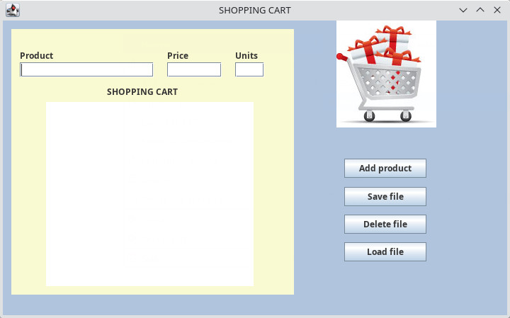

**Solution:**

import javax.swing.JFrame;

import javax.swing.JPanel;

import javax.swing.border.EmptyBorder;

import javax.swing.JLabel;

import javax.swing.JTextField;

import javax.swing.JButton;

import javax.swing.JTextArea;

import javax.swing.JOptionPane;

import javax.swing.ImageIcon;

import java.awt.EventQueue;

import java.awt.event.ActionListener;

import java.awt.event.ActionEvent;

import java.awt.Font;

import java.awt.Color;

import java.io.BufferedReader;

import java.io.BufferedWriter;

import java.io.File;

import java.io.FileNotFoundException;

import java.io.FileReader;

import java.io.FileWriter;

import java.io.IOException;

/**

* =====================================================================

* Program to manage PRODUCTS in a shopping cart (GUI version)

* @author Abelardo Martínez

* =====================================================================

*/

public class frmShoppingCart extends JFrame {

/*

* ---------------------------------------

* GLOBAL VARIABLES AND CONSTANTS

* ---------------------------------------

*/

private static final long serialVersionUID = 1L;

//Path constant. We assume that our file is located in the folder "Documentos"

static final String PATH = "/home/"+System.getProperty("user.name")+"/Documentos/";

static final String FILENAME = "products.txt";

/*

* ---------------------------------------

* FRAME CREATION AND ATTRIBUTES

* ---------------------------------------

*/

private JPanel panContentPane;

private JTextField txfProduct;

private JTextField txfPrice;

private JLabel lblPrice;

private JLabel lblUnits;

private JTextField txfUnits;

private JTextArea txaProduct;

/*

* Launch the application.

*/

public static void main(String[] stArgs) {

EventQueue.invokeLater(new Runnable() {

public void run() {

try {

frmShoppingCart frame = new frmShoppingCart();

frame.setVisible(true);

} catch (Exception exe) {

exe.printStackTrace();

}

}

});

}

/*

* Create the frame.

*/

public frmShoppingCart() {

setTitle("SHOPPING CART");

setDefaultCloseOperation(JFrame.EXIT_ON_CLOSE);

setBounds(100, 100, 720, 449);

panContentPane = new JPanel();

panContentPane.setBackground(new Color(176, 196, 222));

panContentPane.setBorder(new EmptyBorder(5, 5, 5, 5));

setContentPane(panContentPane);

panContentPane.setLayout(null);

JPanel panel = new JPanel();

panel.setBackground(new Color(250, 250, 210));

panel.setBounds(12, 12, 399, 375);

panContentPane.add(panel);

panel.setLayout(null);

JLabel lblProduct = new JLabel("Product");

lblProduct.setBounds(12, 29, 77, 17);

panel.add(lblProduct);

txfProduct = new JTextField();

txfProduct.setBounds(12, 47, 189, 21);

lblProduct.setLabelFor(txfProduct);

panel.add(txfProduct);

txfProduct.setColumns(10);

lblPrice = new JLabel("Price");

lblPrice.setBounds(220, 29, 77, 17);

panel.add(lblPrice);

txfPrice = new JTextField();

txfPrice.setBounds(220, 47, 77, 21);

txfPrice.setColumns(10);

panel.add(txfPrice);

lblPrice.setLabelFor(txfPrice);

lblUnits = new JLabel("Units");

lblUnits.setBounds(316, 29, 77, 17);

panel.add(lblUnits);

txfUnits = new JTextField();

txfUnits.setBounds(316, 47, 41, 21);

lblUnits.setLabelFor(txfUnits);

txfUnits.setColumns(10);

panel.add(txfUnits);

JLabel lblShoppingCart = new JLabel("SHOPPING CART");

lblShoppingCart.setBounds(135, 80, 131, 17);

panel.add(lblShoppingCart);

txaProduct = new JTextArea();

txaProduct.setBounds(49, 103, 293, 260);

txaProduct.setEditable(false);

txaProduct.setFont(new Font("Dialog", Font.PLAIN, 16));

txaProduct.setColumns(3);

panel.add(txaProduct);

JButton btnAddProduct = new JButton("Add product");

btnAddProduct.setBounds(482, 195, 116, 27);

btnAddProduct.addActionListener(new ActionListener() {

public void actionPerformed(ActionEvent e) {

AddProduct(); //add the current product to the textArea

}

});

panContentPane.add(btnAddProduct);

JButton btnSaveToFile = new JButton("Save file");

btnSaveToFile.setBounds(482, 235, 116, 27);

btnSaveToFile.addActionListener(new ActionListener() {

public void actionPerformed(ActionEvent e) {

SaveProducts(); //save all the products to a file

}

});

panContentPane.add(btnSaveToFile);

JButton btnDeleteFile = new JButton("Delete file");

btnDeleteFile.addActionListener(new ActionListener() {

public void actionPerformed(ActionEvent e) {

DeleteProductsFile(); //delete the products file

}

});

btnDeleteFile.setBounds(482, 274, 116, 27);

panContentPane.add(btnDeleteFile);

JLabel lblImgLogo = new JLabel("");

lblImgLogo.setIcon(new ImageIcon("/home/"+System.getProperty("user.name")+"/eclipse-workspace/U1NAT23ShoppingCart/img/shoppingcart.jpg"));

lblImgLogo.setBounds(471, 0, 141, 151);

panContentPane.add(lblImgLogo);

JButton btnLoadFile = new JButton("Load file");

btnLoadFile.addActionListener(new ActionListener() {

public void actionPerformed(ActionEvent e) {

LoadProductsFile();

}

});

btnLoadFile.setBounds(482, 313, 116, 27);

panContentPane.add(btnLoadFile);

}

/**

* ----------------------------------------------

* METHODS: ADD, SAVE, DELETE AND LOAD PRODUCTS

* ----------------------------------------------

*/

/*

* ---------------------------------------

* Add a product to the shopping cart.

* ---------------------------------------

*/

public void AddProduct() {

//check if product name is empty

if ((txfProduct.getText()=="") || (txfProduct.getText()== null))

return;

//Add product to the text area with an ending carriage return (to split lines). Fields are separated by tab.

txaProduct.append(txfProduct.getText()+"\t"+txfPrice.getText()+"\t"+txfUnits.getText()+"\n");

//Clear the product fields

txfProduct.setText("");

txfPrice.setText("");

txfUnits.setText("");

txfProduct.requestFocus(); //set the focus to the product name field

}

/*

* -------------------------------------------------------------------------------------------

* Save the list of products contained inside the shopping cart to a file with TXT extension

* -------------------------------------------------------------------------------------------

*/

public void SaveProducts() {

try {

/*

* 1st STEP: Create a buffer (file) to store the products

*/

// We use a BufferedWriter. Many other options are valid.

BufferedWriter bwFile = new BufferedWriter(new FileWriter(PATH+FILENAME));

/*

* 2nd STEP: For every product, add a line to the buffer (file)

*/

//traverse the text area line by line

String stCompleteLines = txaProduct.getText();

//split the content in lines of products

String [] stProductLines = stCompleteLines.split("\n");

for (String stSingleLine :stProductLines) {

bwFile.write(stSingleLine.toString() + "\n"); //write the current product to file

}

bwFile.close();

//dialog frame to display messages

JFrame frmDlgInfo = new JFrame();

//show a message informing that the file was saved successfully

JOptionPane.showMessageDialog(frmDlgInfo, "The file was saved successfully");

txfProduct.requestFocus(); //set the focus to the product name field

/*

* DO NOT FORGET TO SET THE PROPER EXCEPTION HANDLING HERE

*/

} catch (FileNotFoundException fne) {

//show a dialog with the error

JFrame frmDlgInfo = new JFrame();

JOptionPane.showMessageDialog(frmDlgInfo, "File not found");

} catch (IOException ioe) {

//show a dialog with the error

JFrame frmDlgInfo = new JFrame();

JOptionPane.showMessageDialog(frmDlgInfo, "I/O Error");

}

}

/*

* ----------------------------------------

* Delete the products file (if exists)

* ----------------------------------------

*/

public void DeleteProductsFile() {

//ask the user

JFrame frmDlgQuestion = new JFrame();

int iResp = JOptionPane.showConfirmDialog(frmDlgQuestion, "Do you really want to delete the products file?");

if (iResp != 0) //answered NO or cancel. Exit from procedure

return;

//dialog frame to display messages

JFrame frmDlgInfo = new JFrame();

// https://stackoverflow.com/questions/40706380/failed-to-delete-a-file-in-windows-using-java

File fFile = new File(PATH+FILENAME);

if (fFile.delete()) {

JOptionPane.showMessageDialog(frmDlgInfo, "Deleted the file: " + fFile.getName());

} else {

JOptionPane.showMessageDialog(frmDlgInfo, "File not deleted (probably since is open elsewhere): " + fFile.getName());

}

txfProduct.requestFocus(); //set the focus to the product name field

}

/*

* ----------------------------------------------------------------

* Read file (TXT extension) and fill in the text area.

* ----------------------------------------------------------------

*/

public void LoadProductsFile() {

try {

JFrame frmDlgQuestion = new JFrame();

int iResp = JOptionPane.showConfirmDialog(frmDlgQuestion, "Do you really want to load the products file from disk?");

if (iResp != 0) //answered NO or cancel. Exit from procedure

return;

//load the products file

File fFile = new File(PATH+FILENAME);

BufferedReader brFile = new BufferedReader(new FileReader(fFile));

String stLine;

txaProduct.setText(""); //clear the text area contents

while ((stLine = brFile.readLine()) != null)

txaProduct.append(stLine + "\n");

brFile.close();

txfProduct.requestFocus(); //set the focus to the product name field

}

/*

* DO NOT FORGET TO SET THE PROPER EXCEPTION HANDLING HERE

*/

catch (FileNotFoundException fne) {

//show a dialog with the error

JFrame frmDlgInfo = new JFrame();

JOptionPane.showMessageDialog(frmDlgInfo, "File not found");

}

catch (IOException ioe) {

//show a dialog with the error

JFrame frmDlgInfo = new JFrame();

JOptionPane.showMessageDialog(frmDlgInfo, "I/O Error");

}

}

}

**Part 2_ Files and XML**

1. **Introduction**

**Binary formats** do not guarantee data **compatibility** between systems. Therefore, when you want to store data that must be read by applications running on multiple platforms, it is necessary to resort to more standardised formats, such as mark-up languages. These mark-up languages, such as **XML**, are used to solve this problem.

1. **XML language**

XML documents structure information by interspersing a series of tags called **hashtags**.

* hashtags have a certain similarity to an information container
* they can contain other hashtags or textual information so you can subdivide the info in a way that it can be easily interpreted

_Any **data**, whether numeric or Boolean, will have to be **transcribed** in **text mode**, so that whatever the data representation system is, it will be possible to read and interpret correctly the information contained in an **XML file**.

_Characters can also be written using different encoding systems, but XML offers several techniques to avoid this being a problem.

_XML is able to structure any kind of hierarchical information

* 1. **What is XML**



**Main features:**

1) XML stands for **eXtensible Markup Language**

2) **XML** is a markup language much like **HTML**, without predefined tags to use

3) XML was designed to **store** and **transport** **data** (such JSON or CSV does) in a format that can be searched and shared.

4) XML was designed to be **self-descriptive** (intuitive)

5) XML is a **W3C** recommendation (standard)

6) XML is a restricted form of SGML, the **Standard Generalized Markup Language** [ISO 8879]

**Difference between XML and HTML**

* XML was designed to carry data - with focus on what data is.
* HTML was designed to display data - with focus on how data looks.
* XML tags are not predefined like HTML tags are

**Difference Between XML and JSON**



* 1. **Structure of an XML document**
* XML allows us to hierarchise and describe the contents within the document itself.
* XML files are files where the information is organised sequentially and in hierarchical order.
* Information is organised in a hierarchical way, so that elements are related to each other through relationships of parent, child, sibling, parentage, descent, etc…
* XML documents form a tree structure that starts at "the root" and branches to "the leaves".
  + 1. **Correct design rules**

For an XML document to be correct:

* Document must be well formated.
* Document must conform to all XML syntax rules.
* Document must conform to semantic rules.
  + 1. **XML Syntax**

An XML document is a string of characters:

1. **Markup and content**
   1. Strings that constitute markup either begin with the character < and end with a >, or they begin with the character & and end with a ;
   2. Strings of characters that are not markup are content
2. Tag
   1. A tag is a markup construct that begins with < and ends with >. Types of tags:
      1. start-tag: <section>
      2. end-tag: </section>
      3. empty-element tag: <line-break/>
3. Element
   1. An element is a logical document component that either begins with a start-tag and ends with a matching end-tag or consists only of an empty-element tag.
4. Attribute
   1. An attribute is a markup construct consisting of a name–value pair that exists within a start tagor empty-element tag.
   2. An XML attribute can only have a single value and each attribute can appear at most once on each element.

*<img src="valentia.jpg" alt="Valentia" /> <!-- where the names of the attributes are*

*<step number="3">Connect A to B.</step> <!-- where the name of the attribute is "number*

1. XML declaration
   1. XML declaration is not a tag. It is used for the transmission of the meta-data of a document

*<?xml version="1.0" encoding="UTF-8"?> <!-- where version means used version XML*

1. Comments
   1. Comments cannot appear before the XML declaration.

*<!-- Comment -->*

* + 1. **Entities**

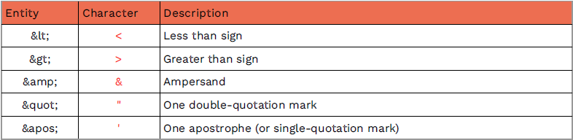XML offers methods (called entities) for referring to some special reserved characters (such as a greater than sign which is used for tags:

* + 1. **Displaying XML**

XML is usually used for descriptive purposes, but there are ways to display XML data.

One way to **style XML** output is to specify CSS to apply to the document using the xml stylesheet processing instruction.

*<?xml-stylesheet type="text/css" href="stylesheet.css"?>*

Another more powerful way to display XML: the **Extensible Stylesheet Language Transformations (XSLT)** which can be used to transform XML into other languages such as HTML.

*<?xml-stylesheet type="text/xsl" href="transform.xsl"?>*

* + 1. **Examples**

*<?xml version="1.0" encoding="UTF-8"?>*

*<message>*

*<warning>*

*Hello World*

*</warning>*

*</message>*

1. **Working with XML files**

XML files can be used to:

* Provide data to a DB.
* Store information in special databases.
* Configuration files.
* Exchange of information in web environments (SOAP).
* Execution of commands on remote servers

To carry out any of these operations, a programming language that provides XML with functionality is necessary.

* 1. XML processor or parser

To access XML files, read their content or alter their structure, an XML processor or XML parser is used.

An **XML Parser** is a class that aims to **parse** and **classify** the content of an XML file by extracting the information contained in each of the hashtags and relating it according to its position within the hierarchy.

There are two main ways to work with XML files using Java:

- SAX

- DOM

* + 1. **Sequential parsers**

Sequential parsers, which allow content to be extracted as the opening and closing hashtags are discovered, are called syntactic parsers. In Java, the most popular is SAX.

**Advantages**:

* It’s very fast.
* It DOES NOT load the whole document into memory.
* The best choice for reading large documents.

**Disadvantages**:

* It must read the whole document at each query.
  + 1. **Hierarchical parsers**

End applications that must work with XML data tend to use **hierarchical parsers** because they perform a **sequential parsing** that allows them to classify the content, they are stored in RAM following the hierarchical structure detected in the document.

**Advantages**:

* Simply put, a DOM parser works on the entire XML document.
* It’s ideal for applications requiring continuous querying of the data.

**Disadvantages:**

* It loads the whole document into memory.
* Not suitable for large documents.
  + 1. **SAX versus DOM**



1. SAX parser

* The XML-DEV mailing group developed a Simple API for XML also called the SAX, which is an event-driven online algorithm for parsing XML documents.
* SAX (Simple API for XML) is a set of classes and interfaces that provide a tool for processing XML documents.
* SAX is a way of reading data from an XML document that is an alternative to the Document Object Model’s mechanism (DOM)
* SAX parsers work on each element of the XML document sequentially, issuing parsing events while passing through the input stream in a single pass.
* SAX is a programming interface for processing XML files based on events
* Processes documents state independently
* SAX is more complex to program than DOM, however it offers lower memory consumption, making it more suitable for processing large XML files
  1. **Read XML files with Java**

The SAX API is fully included within the JRE.

* If we give the XML file to the API it will not do anything.
* On load, some methods will be called for every item found.
* All these methods are defined in the DefaultHandler



SAX parser works on following **events**:

* startDocument
* startElement
* characters
* comments
* processing instructions
* endElement
* endDocument

Commonly used **methods** of SAX XML Parser:

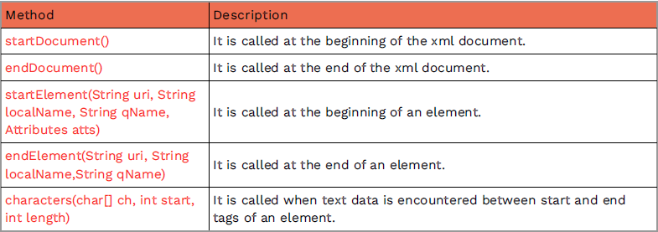

**Steps** to read a file using SAX:

1. Create a class to extend ***org.xml.sax.helpers.DefaultHandler***, and override the startElement, endElement and characters methods to print all the XML elements, attributes, comments and texts.

2. Create a new class that will be in charge of the main execution of our application (MAIN):

1. Create a ***SAXParserFactory*** instance, as determined by the setting of the ***javax.xml.parsers.SAXParserFactory*** system property. The factory to be created is set up to support XML namespaces by setting ***setNamespaceAware*** to true, and then a SAXParser instance is obtained from the factory by invoking its ***newSAXParser()*** method.

2. Create an object of the ***DefaultHander*** class we have just created.

3. Use the parse method of our ***SAXParserFactory*** to read the file. We pass as parameters the name of the XML file and the object of the DefaultHander class.

3. **Output**:

1. This could be the result placing a simple println on every method but we could store the information on a database, save it on another device or send it elsewhere.



* 1. **Example of reading**

1. The first thing we will do is to import all the necessary classes and interfaces.

*import org.xml.sax.Attributes;*

*import org.xml.sax.helpers.DefaultHandler;*

*import org.xml.sax.SAXException;*

1. Then we create a class that extends **DefaultHandler** to handle read events. This class provides the default implementation for all its methods, the programmer must define those methods to be used by the application. This is the class we will extend to create our XML Parser.

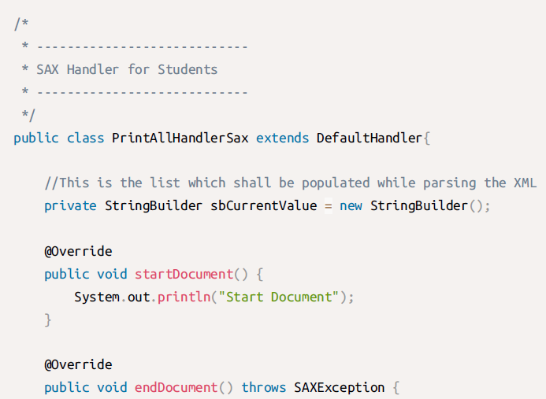

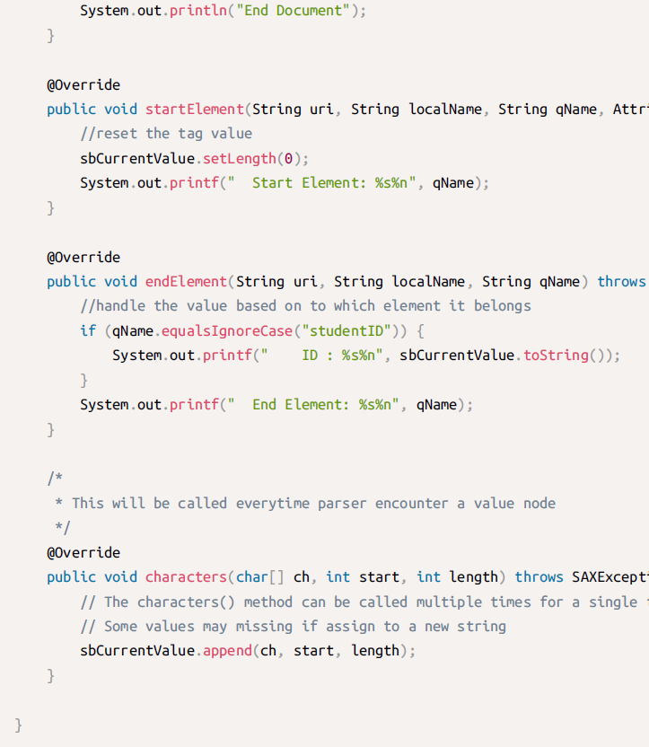

1. Once we have our own handler, we create a new class that will be in charge of the main execution of our application (MAIN)

* Create a SAXParserFactory instance, as determined by the setting of the javax.xml.parsers.SAXParserFactory system property. The factory to be created is set up to support XML namespaces by setting setNamespaceAware to true, and then a SAXParser instance is obtained from the factory by invoking its newSAXParser() method.

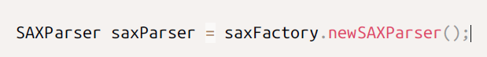

* Create an object of the DefaultHander class we have just created.



* We must tell our XML Parser to use an instance of it to read the file. Once we have the source created and the ContentHandler assigned we will proceed to read the file simply by using the Parse method of our XML processor.

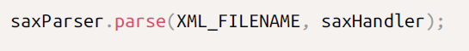

1. Complete code of the main class:

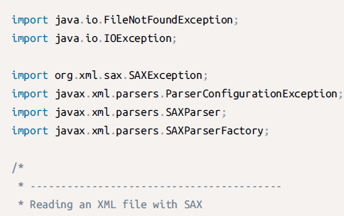

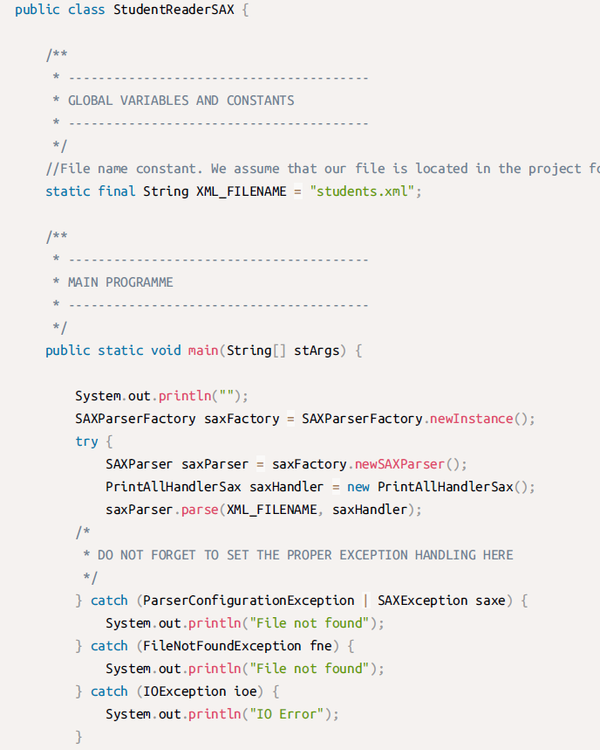

1. **DOM parser**

The **DOM** defines a standard for accessing and manipulating documents: "The W3C Document Object Model (DOM) is a platform and language-neutral interface that allows programs and scripts to dynamically access and update the content, structure, and style of a document."

**DOM** stores all the data of the XML document in memory in a hierarchical tree structure.



* 1. **The DOM structure**

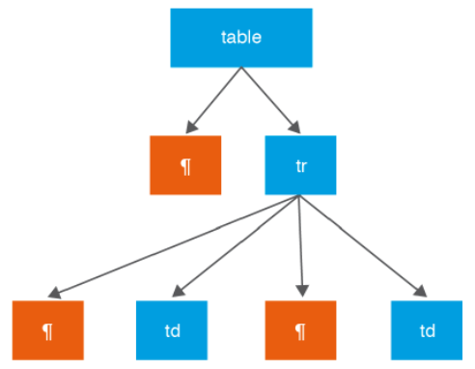The DOM structure takes the form of a tree, where each part of the XML is represented as a node.

The main node representing the entire XML is called document, and the various hashtags, including the root tag, are known as element nodes. The textual content of a hashtag is instantiated as a node of type TextElement and the attributes as nodes of type Attribute.

Each specific node has methods to access its specific data.

The resulting DOM obtained from an XML ends up being an exact copy of the file but arranged in a different way.

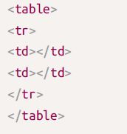Both in the XML and in the DOM there will be non-visible information, such as carriage returns.

1. Representation of a DOM object with **carriage returns** →
2. Representation of a DOM object **without carriage returns**. ↓

The absence of carriage returns in the file also implies the absence of nodes containing the carriage returns in the DOM structure.

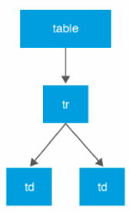

1. 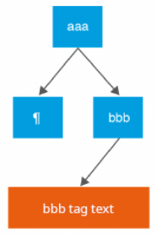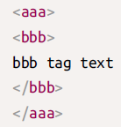DOM representation of a **hashtag with text**: another aspect to bear in mind about mapping XML files is that the textual content of hashtags is captured in the DOM as a child node of the hashtag container. →

The **Document interface** provides a set of **methods** to select different parts of the **tree** from the **hashtag** name or an identifying attribute. The parts of the tree are returned as **Element objects**, which represent a **node** and all its children. In this way, we can explore parts of the tree without having to go through all the nodes.

* 1. **Manage XML files with java**

To work with DOM in Java we will make use of the packages:

* org.w3c.dom
* javax.xml.parsers

Abstract classes that we need to extend to work with DOM:

* DocumentBuilderFactory
* DocumentBuilder

To generate an XML file from a DOM tree we will use the javax.xml.transform package. This package allows to specify a source and a result:

* Files
* Data streams
* DOM nodes
* Etc.

Java programs using DOM need to make use of the following **interfaces**:

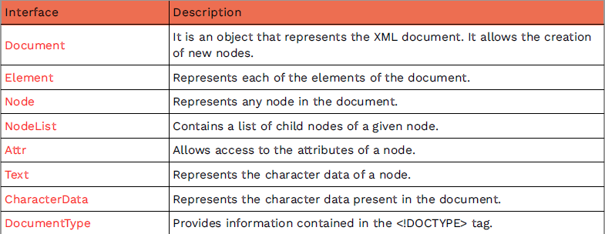

**File access** with DOM:

* DOM parser is intended for working with XML as an object.
* This object is a graph (a tree like structure) in memory so called “Document Object Model (DOM)“.
* The procedure is quite similar to the one used in JavaScript:
  + First, the parser goes through the whole XML file creating DOM objects corresponding to the nodes in the XML file.
    - These DOM objects are linked together in a tree like structure.
  + Once the parser is done with parsing process we get this tree-like DOM object structure.
    - Now we can “walk” the DOM structure back and forth as we want to get/update/delete data from it.
  1. **Reading with DOM**

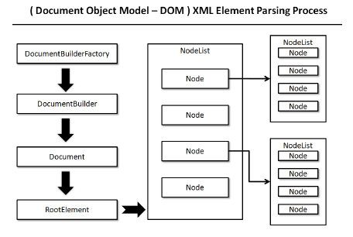

Steps to **read** an XML file with DOM:

● Create DocumentFactory (load XML to memory)

● Create DocumentBuilder

● Create Document object

● Extract root element

● Walk through the document

➔ Examine attributes

➔ Examine sub-elements

➔ Repeat recursively

**Examples of reading:**

To read an XML document using DOM we must create an instance of DocumentBuilderFactory to build the parser and, through it, load the document.

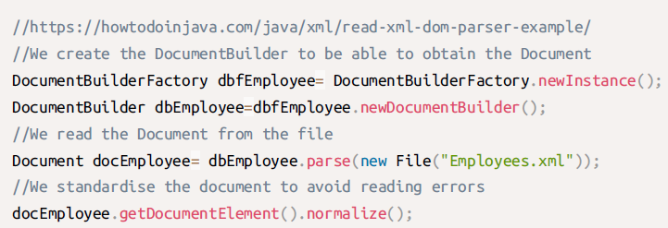

We then create a list as all the elements used using the class NodeList.

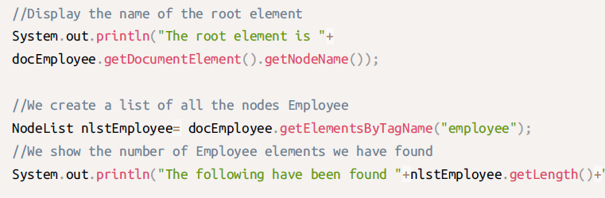

+" employees

Finally, using a loop we traverse the NodeList and display its contents.

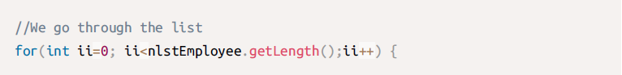

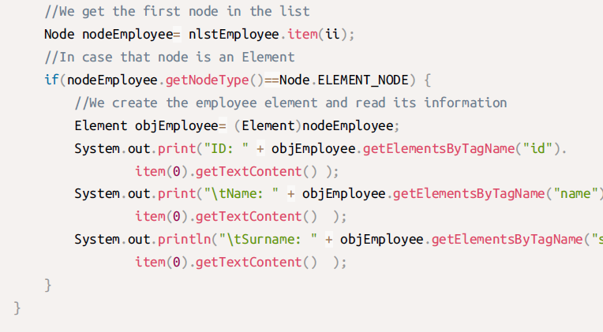

surname

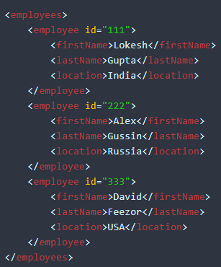



* 1. **Writing with DOM**

Next we are going to create an XML file of employees. The first thing to do is to import the necessary packages.

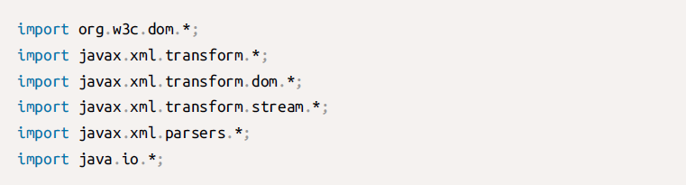

Then we will create the Document in which we are going to insert our employees.

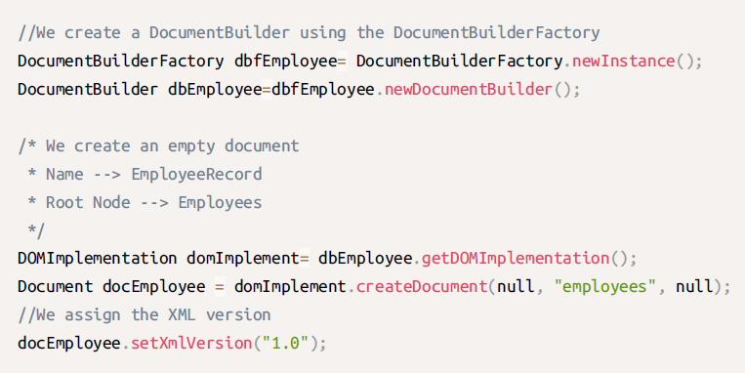

And we will create each of the employees with their data.

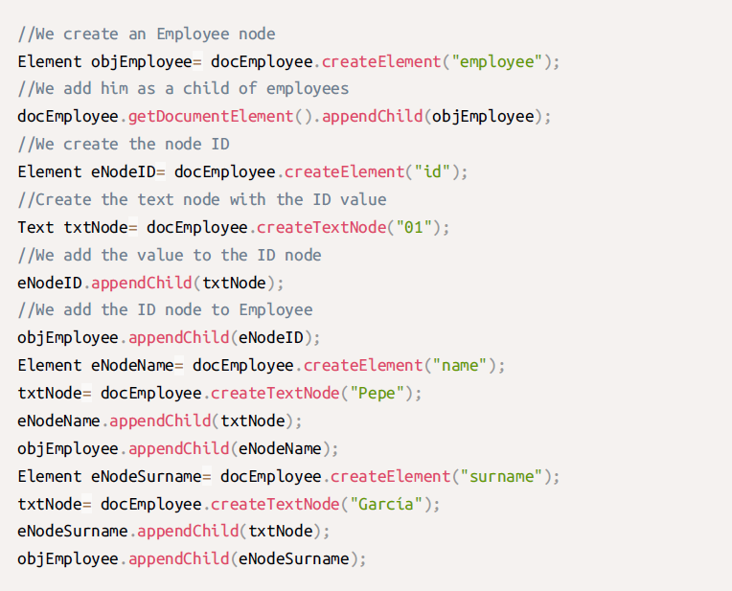

Finally, we must write our Document to disk.

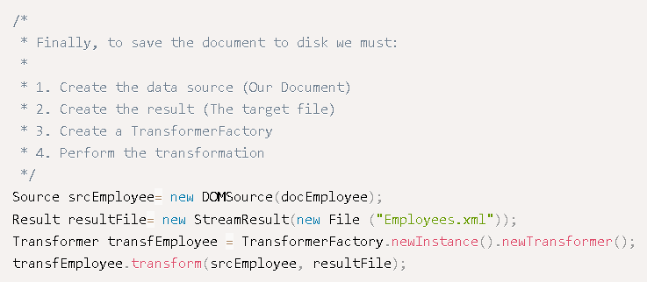

In the same way that we use the Transform class to send our Document to file, we can use it to display it via the standard output.

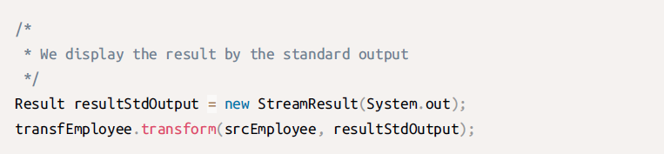

* 1. **File modification with DOM**

Steps to change several values only within specific node(s):

●Create a Document doc (load XML to memory).

●Loop for all subnodes.

● If specific node(s) is found, change the values of its subnodes.

●Save XML to disk.

1) Creation (load XML to memory): ↓ 2) XML structure walkthrough: ↓





3) Update changes and save: ↓



1. **XSL language**

**XSL** is a styling language for XML:

●XSL stands for eXtensible Stylesheet Language.

●XSL is a styling language for XML just like CSS is a styling language for HTML.

●XSLT stands for XSL Transformation, and it is used to transform XML documents into other formats (XML => HTML)

It consists of 3 **parts**:

• XSL Transformations (XSLT). A language for transforming XML;

• The XML Path Language (XPath). An expression language used by XSLT (and many other languages) to access or refer to parts of an XML document.

• XSL Formatting Objects (XSL-FO). An XML vocabulary for specifying formatting semantics.

**Examples:**

example.xml example.xml

example.xsl

↓

 OUTPUT

* 1. **XSLT**

**XSLT** (eXtensible Stylesheet Language Transformations) is an XML-based language used, in conjunction with Specialized processing software, for the transformation of XML documents.

The **original** **document** is not changed; rather, a new XML document is created based on the content of an existing document. The new document may be serialized (**output**) by the processor in standard XML syntax or in another format, such as HTML or plain text.

XSLT is most often used to convert data between different XML schemas or to convert XML data into web pages or PDF documents.

* 1. **Using XSL to transform documents**

In this example, we will convert XML to HTML using XSLT language.

 XML documentation

We whant to get this output (HTML) ↓



 HTML documentation

 HTML + CSS

**Now we define the XSL file:**

- Basically, *xsl:template match=”/”* executes at the beginning, adding the headers of the document and the table.

- Then*, xsl:for-each* node matching the criteria, a new row (tr) is added with its columns (tr) and data (xsl:value-of).

**→** 

**We apply the transformations:**

To transform the XML into this particular HTML we have to join the XML, with the XSL and let Java do the rest.

We must create:

● One StreamSource for the XML

● One StreamSource for the XSL

● One StringWriter to hold the transformation

● One FileWriter for the resulting HTML

A TransformerFactory instance will do the rest in a very intuitive way. Keep in mind all the exceptions you have to manage.

